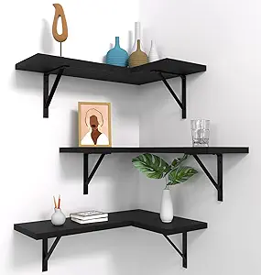**Floating Corner Shelves Set of 3**

The Floating Corner Shelves Set of 3 is an elegant and functional storage solution designed to optimize corner spaces in any room. These sleek, wall-mounted shelves provide a modern, minimalist aesthetic while offering ample space for displaying decorative items, books, or plants. Made from high-quality materials such as wood or metal, the shelves are durable and easy to install with the included mounting hardware. Ideal for living rooms, bedrooms, kitchens, or bathrooms, this set of three shelves helps keep your space organized and stylish, adding a touch of sophistication to any corner.

.